Conspiracy Belief Systems:

A Cross-National Psychological Network Analysis of Conspiracism

Abstract
The study of Conspiracy Mentality (CM) has been shaped by three central debates: its theoretical definition, its causal relationship with Conspiracy Beliefs (CB), and its empirical utility. These debates have largely guided the field, yet the relationship between CM and CB remains undertheorized and insufficiently tested. To address this, we draw on cross-national data from eight countries (n = 20,051) and examine the structure of conspiracy belief systems using network psychometrics. We test three competing hypotheses: whether CM and CB are empirically distinct constructs; whether CM functions as the latent cause of CB; or whether CB, instead, drives CM. Our findings show that CM and CB form separate dimensions across all countries, contradicting the isomorphic view that treats them as interchangeable. Moreover, CM emerges as a peripheral component within belief networks, while CB displays greater centrality and explanatory power. These results challenge the dominant latent variable model in which CM precedes CB, suggesting instead that CB may shape CM, or that conspiracist thinking arises through self-reinforcing networks of belief. We argue that future research should move beyond generalized notions of conspiracist mentality and focus instead on theorizing and testing the specific psychological and structural mechanisms through which conspiracy beliefs are organized and maintained.
Keywords: Conspiracy Beliefs; Conspiracy Mentality; Comparative; Causal mechanism; Validity

1. Introduction
"It has already been so several times in history. What was conceived as ideal and lofty became coarse and material" (Pasternak et al., 2002).
Conspiracy beliefs (CB) circulate widely and have profound social consequences (Pilch et al., 2023). CB are epistemically risky narratives that explain significant social events by attributing them to powerful actors secretly plotting malevolent or illicit actions (Douglas & Sutton, 2023). A robust finding in conspiracy research is that people seldom endorse just one theory in isolation; instead, they exhibit a polarized pattern—either believing multiple conspiracy beliefs or rejecting them broadly (Goertzel, 1994). This suggests that belief in conspiracy theories is not a continuous spectrum, but rather a discrete pattern of acceptance or rejection. Early explanations explained this pattern through a network metaphor, where CB reinforce each other, forming tightly interlinked and self-sustaining “monological” belief systems. Over time, however, this perspective was replaced by a common cause model, which posits a generalized conspiratorial mindset—Conspiracy Mentality (CM)—as the latent force behind CB (Bruder et al., 2013). This shift led to the validation of numerous CM scales, each designed to capture an ideal-typical and pure tendency to believe all CB (Brotherton et al., 2013; Imhoff & Bruder, 2014; Kay & Slovic, 2023; Lantian et al., 2016; Stojanov & Halberstadt, 2019). This had two key consequences. First, research interest shifted away from validating CB scales. Second, the pursuit of measurement purity led to the reification of the latent hypothesis, transforming it from a testable assumption into a substitute for a theory on why people hold CB. This study empirically tests whether CM can drive CB by developing a comparative analytical strategy grounded in network psychometrics (Epskamp, Maris, et al., 2018).
The Article is structured as follows. We begin by reviewing three central debates about Conspiracy Mentality: its conceptual definition, the causal ordering between CM and CB, and its practical value as a construct. Empirically, we draw on two metric-invariant, cross-national scales: the GCB-5 (Dagnall et al., 2023) to index CM and the COMP-CB (Mancosu et al., 2025) to index CB. In representative, cross-sectional samples (n = 20,051, eight countries), we examine whether CM and CB emerge as separate dimensions of conspiracism (H0), whether CM might function as the latent variable of CB (H1), or vice versa (H2). Our analysis relies on psychological network models to isolate the unique variance shared between CM and CB items (Borsboom et al., 2021). Unlike latent variable models, which assume that correlations among items are spurious once the underlying latent construct is accounted for, the network approach recognizes CB as interdependent elements within structured belief systems (Enders et al., 2021; Williams et al., 2022). Our findings confirm that CB and CM are distinct constructs, but challenge the dominant view that CM leads to CB. Indeed, CM appears peripheral in CB networks, while CB shows stronger structural integration within the conspiracy belief system. If a latent generative mechanism exists, our results suggest it operates in the opposite direction of what has been theorized, with CB shaping CM. Alternatively, our findings are consistent with a network mechanism, where CB sustain themselves independently of a generalized conspiratorial mindset.

2. Background: Three Debates on CM
We review three debates on CM. Section 2.1 examines conflictual definitions of CM. Section 2.2 explores how these differing interpretations shape competing theories about the causal link between CM and CB. Section 2.3 argues that efforts to improve the conceptual clarity of CM must precede discussions of its empirical utility.

2.1 One and Triune: the theoretical status(es) of CM
CM is inconsistently defined. It has been framed as a stable dispositional tendency, a generalized political attitude, or a worldview. These overlapping definitions create conceptual ambiguity¹ and render causal explanations on the link between CM and CB similar to black box explanations (Nera, 2024).
One perspective sees CM as a stable, independent construct that underlies conspiracist thought. CM is described as a latent (Imhoff, 2024), and generic (Enders et al., 2023) disposition to endorse all kinds of CB. Therefore, CM represents the “relatively pure” (Imhoff et al., 2022, p. 3) tendency to see plausibility in real-world conspiracies, independently of the specific content of these narratives. CM is measured using scales emphasizing institutional distrust, hidden connections, and covert control² (Brotherton et al., 2013; Bruder et al., 2013; Imhoff & Bruder, 2014; Kay & Slovic, 2023; Lantian et al., 2016; Stojanov & Halberstadt, 2019; Uscinski & Parent, 2014). These scales, validated primarily through criterion validity, consistently show that higher CM scores correlate with stronger CB endorsement. Longitudinal data further suggest CM remains stable over time, strengthening the case for CM as a persistent psychological characteristic rather than a transient mood (Wang & Van Prooijen, 2023).
A second perspective conceptualizes CM as a political attitude, an idea first introduced by Imhoff and Bruder (2014, p. 1). However, in the very same work (ibid., p. 26), CM is also defined as “the propensity to believe in conspiracy theories”, creating an inherent ambiguity. Despite Imhoff later moving away from this view (Imhoff, 2024), the political attitude account remains influential. Indeed, CM has been recently described as the “the abstract, ‘generalized political attitude’ in which forces are perceived to conspire to manipulate world events” (Sutton et al., 2024, p. 50). Importantly, this characterization challenges the assumption that CM scales are superior to CB ones due to their purity and ideological neutrality (Imhoff et al., 2022; see Section 2.3). If CM is a political attitude, its correlations with ideology or other political beliefs should not be seen as contamination but as meaningful features, given that political attitudes themselves are embedded within belief systems (Brandt & Sleegers, 2021; Converse, 2006). Additionally, some CM scales have been validated through their correlations with Right-Wing Authoritarianism and Social Dominance Orientation (Bruder et al., 2013), or with other socio-political attitudes (Kay & Slovic, 2023). If such correlations substantiate CM’s criterion validity, they cannot simultaneously be dismissed as a flaw in CB measures.
A third perspective conceptualizes CM as a fundamental lens through which people interpret reality. Imhoff (2022, p.1) describes it as a “generalized worldview suspecting conspiracy at play”. This aligns with classic theories of conspiracism. Popper (2019) characterized the conspiracy theory of society as the pervasive belief that major social problems result from intentional manipulation by powerful elites. Similarly, Barkun (2013) asserts the conspiracist mindset is built upon the core assumptions that events are rarely coincidental, appearances are deceptive, and hidden connections link seemingly unrelated occurrences. Some scholars defended the worldview account in opposition to the dispositional one. For instance, Sutton and colleagues (2024, p. 52) affirm that CM “must be surplus to the tendency to endorse conspiracy theories”. Similarly, other scholars caution against reducing CM to a simple tendency toward conspiracist beliefs (Trella et al., 2024). This concern underpins Nera’s (2024) critique, which warns that such a characterization risks circular reasoning, where CM is both defined as a tendency to believe in CB and simultaneously treated as their fundamental cause.
In sum, CM appears One and Triune—a single construct with three competing identities. This theoretical ambiguity entails validating CM scales remains a risky enterprise.

2.2 Data-generation Mechanisms
Despite varying definitions, most research treats CM as an underlying latent force leading to the endorsement of specific conspiracy beliefs. This aligns with a reflective latent variable model (Imhoff, 2024), which assumes there is a common cause that explains manifest correlations between CB (Borsboom et al., 2003). Within this framework, CB are viewed as a causal outcome of CM, rather than independent or self-reinforcing phenomena. A key assumption of this model is indeed local independence: if CM is the latent driver, then controlling for CM should eliminate correlations among CB (see Section 3.2). This model has been widely endorsed in the literature. It can be argued that it operates as the implicit assumptions of all contributions developing CM scales (Brotherton et al., 2013; Bruder et al., 2013; Imhoff et al., 2022; Imhoff & Bruder, 2014; Kay & Slovic, 2023; Stojanov & Halberstadt, 2019). Perhaps the clearest articulation of CM as a latent driver comes from Imhoff (2024, p.61), who suggests that “If we are interested in the latent variable behind endorsing conspiracy theories – and not the latent variable behind endorsing epistemically questionable or ideologically laden statements – measures of conspiracy mentality will prove more useful than the frequently employed (often mostly implausible) specific conspiracy theories”. However, some scholars caution against treating CM as the sole determinant of CB endorsement, as “it is surely not realistic to regard conspiracy mentality as the cause of belief in conspiracy theories” (Sutton et al., 2024, p. 54). Other researchers have conformed to a latent explanation, but without relying on CM. For example, one work suggests that the belief in deceptive officialdom, might serve as the “nuclear idea” underpinning all conspiracy beliefs (Wood et al., 2012, p. 771). These critical perspectives seem to relax the key assumption of latent models by suggesting that CM, while important, can not be the sole driver of CB.
Recent empirical evidence has begun to undermine the core assumptions of the latent variable model more directly. Indeed, longitudinal research has demonstrated that CB can lead to increases in CM. For instance, one contribution has shown that exposure to COVID-19 conspiracy theories can increase individual scores on a CM scale (Granados Samayoa et al., 2022). Complementary, another study showed that while partisan-specific CB increased following the polarized 2020 U.S. elections, CM remained stable, suggesting that CB can fluctuate independently of CM (Wang & Van Prooijen, 2023). Furthermore, a recent contribution has used a three-wave panel study to show that CM predicts CB, but also that CB influence CM, albeit to a lesser extent (Strömbäck et al., 2024). Therefore, other studies have relaxed the latent view by proposing a bidirectional causal model, where CB and CM mutually reinforce each other (Sutton et al., 2024). This perspective suggests that individuals may inductively generalize from specific CB to develop a broader conspiracist mindset, or deductively apply an existing CM to interpret new conspiracy theories (Imhoff, 2024; Sutton et al., 2024). Experimental evidence supports this feedback loop, as manipulations increasing CM have been shown to alter CB endorsement, and vice versa (Trella et al., 2024). Whether these findings are interpreted as evidence for a reversed latent model (where CB drives CM), CB variations independent of CM, or a circular relationship, they collectively pose a direct challenge to the validity of CM scales (see Section 2.3).
A radically different explanation comes from the network approach, particularly Goertzel’s (1994) monological belief system hypothesis. This perspective suggests that CB functions as a self-reinforcing belief system, where adopting one CB increases the plausibility of others, independent of a latent CM factor. Individuals might use CB as evidence for one another, creating a closed-loop of interlinked beliefs that resist falsification. Empirical support for this model remains moderate. A notorious study has found that belief in contradictory CB positively correlates, suggesting that people may endorse conspiracy beliefs without concern for internal consistency and regardless of the content of these narratives (Wood et al., 2012). However, this interpretation has been challenged, with evidence showing that correlations among contradictory CB are primarily driven by those who reject most conspiracies (Van Prooijen et al., 2023). One work directly tested the fit of the network model against a latent variable model, finding stronger support for CB interdependence (Williams et al., 2022). Yet, the study relied on cross-sectional data, and the network model only marginally outperformed a unidimensional factor model. Recent longitudinal research provides the first direct test of the monological model’s causal assumption (Williams et al., 2025). Across two multi-wave panel studies, random intercept cross-lagged panel models have shown significant cross-lagged effects, indicating that belief in a conspiracy theory at one wave predicts increased CB at the next wave. While these effects were modest, they align with the monological model.
In sum, the causal relationship between CB and CM remains debated. Confronted with the persistent finding that CB are positively correlated, the field has shifted from the monological view, which attributes these associations to a self-reinforcing belief system, to the reflective latent model, which posits CM as the underlying cause of these correlations. At the heart of this debate is a key distinction in causal mechanisms. Latent models characterize correlations between CB as spurious. In contrast, network models depict these interconnections as causal. Yet these positions need not be mutually exclusive. Just as current approaches in intelligence research acknowledge both a general “g-factor” and dynamic interactions among cognitive abilities (Van Der Maas et al., 2006), and as modern psychopathology integrates latent vulnerabilities with symptom-to-symptom feedback loops (Borsboom, 2017), a hybrid framework for conspiracism could recognize CM as a broad predisposition while also allowing for direct, mutually reinforcing connections among specific beliefs.

2.3 Usefulness Versus Validity
Recent debates on CM have moved from theoretical concerns to an instrumentalist perspective, where the focus is not on what CM is, but on whether it is useful. This shift is captured by Imhoff (2024, p. 61), who suggests that: “ultimately, this is the core criterion of whether a concept is valuable: whether it is useful”.
Supporters of CM contend that it offers a purer measure of conspiracism, free from ideological contamination. Compared to CB scales, CM distributions are more stable over time and normally distributed (Imhoff et al., 2022). Therefore, CM captures a general tendency to perceive hidden plots behind world events, rather than belief in specific —and real— conspiracy theories (Imhoff, 2024). Proponents also emphasize CM’s cross-cultural applicability, as it measures conspiracist thinking independently of specific, culturally bound, and politically leaning conspiratorial narratives (Bruder et al., 2013; Dagnall et al., 2023). Similarly, Brotherton (2013) argues that CM offers better content validity, assessing general beliefs untied to any particular story circulating in the public sphere.
Critics argue that CM is too abstract and poorly defined, making it a weak explanatory tool. Unlike CB, which carries epistemic risks (Douglas & Sutton, 2023), CM items are vague and lacking clear falsifiability (Sutton & Douglas, 2020; Trella et al., 2024). Furthermore, the lack of a clear definition implies CM produces black-box explanations, providing little insight into the causal mechanism leading to CB (Nera, 2024). Some also question CM’s dimensionality, suggesting it may be bidimensional, composed of negative attitudes toward the public and the belief that populations are kept in ignorance (Nera, 2024) or that it reflects both rational and irrational skepticism (Stojanov & Halberstadt, 2019).
In our view, however, the key issue is not whether CM is useful, but whether it is valid. In psychometrics, validity is often conflated with validation, leading to the mistaken assumption that an instrument is valid simply because it correlates with semantically adjacent constructs (Borsboom et al., 2009). This results in problematic conclusions, such as assuming a test validly measures anything with which it correlates, or that higher correlations imply greater validity. This logic underpins criterion validity, “one of the most serious mistakes ever made in the theory of psychological measurement” (Borsboom et al., 2004, p. 1065). For CM scales to be valid, they must be based on a clear conceptual definition (what CM actually is) and a causal explanation of how individuals high in CM come to endorse specific CB. This requirement follows directly from the realist ontology of latent variable models advocated by Imhoff (2024), where validity demands (1) that the attribute being measured (CM) exists, and that (2) variations in CM causally influence CB (Borsboom et al., 2009). Without this foundation, correlational evidence will provide no help in assessing CM’s validity. Therefore, the pragmatic shift in the CM debate might be premature.

3. Research Hypotheses
Our review of the literature reveals that conspiracism research has largely revolved around three key debates: the conceptual definition of CM, its causal relationship with CB, and its empirical utility. This article directly engages with these three debates, by testing three research hypotheses with a comparative perspective.
The first step is to establish whether CM and CB are empirically distinct constructs across eight countries. Prior research suggests that respondents interpret CM and CB items differently (Trella et al., 2024), and that they load onto separate factors (Strömbäck et al., 2024). However, an implicit isomorphic assumption that treats CM and CB as interchangeable constructs remains widespread, as many studies continue to rely exclusively on one measure or the other (Nera, 2024). If CM and CB were truly isomorphic, the dominant latent model that positions CM as the causal driver of CB would be invalid. Therefore, this hypothesis is a precondition for the others we investigate.
H0: CM and CB items load on separate latent factors.
Next, we test whether CM functions as the latent variable for CB (Imhoff, 2024). Reflective latent models assume correlations among items are spurious once the underlying latent construct is accounted for (Borsboom et al., 2003). If true, controlling for CM should eliminate the statistical associations we observe among CB.
H1: The CM latent variable cancels out the manifest correlations between CB items
While H1 tests the dominant latent model, it does not account for the alternative possibility that CB, rather than CM, is the underlying driver of conspiracism (Granados Samayoa et al., 2022). Thus:
H2: The CB latent variable cancels out the manifest correlations between CM items

4. Methods
We share data and code at the link: [anonymized; data and code are provided as separate files in our submission materials].

4.1 Data and Measures
This study draws on a cross-national survey conducted in eight countries: Germany, Spain, France, the United Kingdom, Italy, Poland, Sweden, and the United States. These countries were selected to capture a diverse range of political, cultural, and institutional contexts within the Western world. The six EU member states included in the sample collectively represent nearly 70% of the EU population, offering a solid foundation for meaningful comparative analysis. Poland adds geographic and political breadth beyond Western Europe, while the United States provides a crucial transatlantic point of comparison. Data collection was carried out by Dynata using online panels, with approximately 2,500 respondents per country recruited through quota sampling based on gender, age, education, and macro-region to reach national representativeness and ensure sufficient statistical power for country-level and cross-national analyses. Fieldwork was conducted shortly after the 2024 European Parliament elections in five of the EU countries. In France and the United Kingdom, data collection was timed to follow their respective national legislative and parliamentary elections. In the United States, the survey was fielded two weeks after the 2024 presidential election.
Our hypotheses require two distinct measures of conspiracism: one capturing CM, and one assessing belief in specific CB. While prior research on CB has frequently relied on the Belief in Conspiracy Theories Inventory (BCTI; Swami et al., 2010), the cross-national scope of our study demands a more suitable instrument. We therefore adopt the Comparative Conspiracy Beliefs Scale (COMP-CB), a recently developed measure designed to overcome the limitations of existing CB scales (Mancosu et al., 2025). The COMP-CB was constructed using an inductive approach, beginning with a pool of 60 widely circulating but explicitly non-political conspiracy theories. These items were tested in a cross-national pilot study and then validated in a large, representative comparative survey. Using structural equation modeling and measurement invariance testing, the item pool was refined to a final set of eight items that exhibited strong and stable factor loadings across all national contexts. The resulting scale demonstrates excellent internal consistency and achieves metric invariance, allowing for valid cross-country comparisons. By focusing on real-world, non-political conspiracies, the COMP-CB avoids the political bias and contextual specificity that limit many existing belief measures (Imhoff et al., 2022).
CM is measured using the five-item Generic Conspiracist Beliefs Scale (GCB-5; Kay & Slovic, 2023). We selected this instrument for two reasons: first, unlike other CM scales (Brotherton et al., 2013; Stojanov & Halberstadt, 2019), it is unidimensional and can be reliably summarized by a single factor; second, previous research has demonstrated its cross-national comparability (Dagnall et al., 2023). Table 1 presents the wording and labels of the CB and CM items, each measured on a 1 (“strongly disagree”) to 5 (“strongly agree”) scale, with no option to skip or respond with “don’t know”.

Table 1: Label and wordings of survey items
Scale | Question | Label
COMP-CB | Governments and the nuclear industry are intentionally poisoning the public with radioactive food | rad_food
COMP-CB | AIDS was created by the CIA and deliberately spread by the WHO via polio inoculations in Africa to try to reduce the world population | aids
COMP-CB | The United States Department of Defense (DOD) is experimenting with ELF (Extremely Low Frequency) devices to control people's minds | elf
COMP-CB | The vaporous contrails left by commercial jets flying through cold air pockets are actually chemtrails which disperse harmful chemical-biological agents | chemtrails
COMP-CB | The United Nations secret aim is to eliminate and invade sovereign nations with 'peacekeeper' troops to create a World Government | worldgov
COMP-CB | The world is secretly ruled by the extremely powerful bankers Rothschild family. | rothschild
COMP-CB | Monsanto Company is secretly maneuvering to control the world's food supply using GMOs | monsanto
COMP-CB | The 2014 Ebola epidemic was deliberately contrived by Big Pharma in order to make profits | ebola
GCB-5 | States allow/commit acts of terrorism on their soil, concealing their involvement | government
GCB-5 | Evidence of contact with aliens is hidden from the public | aliens
GCB-5 | Many advanced technologies that would damage today's big industry are hidden | technology
GCB-5 | A small group secretly manipulates world events | elite
GCB-5 | New drugs or technologies being conducted on citizens without their knowledge | drugs
Caption: Wording of the COMP-CB (CB) and GCB-5 (CM) scales. Labels are used in the plots (Article and Supplement)

4.2 Analytical Strategy
This article relies on network psychometric models to examine the structure of conspiracy belief systems. Network models are especially well-suited to address the central question of this study because they allow for the direct modeling of associations among observed variables without assuming an underlying latent structure (Borsboom et al., 2021). In contrast to traditional reflective latent variable models, which treat observed variables as interchangeable indicators of a common cause, network models conceptualize psychological constructs as systems of interrelated components that may mutually interact. This framework is particularly advantageous for testing our competing hypotheses: whether CM and CB are empirically distinct constructs (H0), whether CM causally shapes CB (H1), or whether CB instead drives CM (H2). In addition, network analysis enables us to visualize belief systems, identify their most central components, and statistically compare structural features across national contexts. In the remainder of this section, we outline the specific modeling strategies used to test each hypothesis.
We test H0 using Exploratory Graph Analysis (EGA; Golino et al., 2017), and we corroborate results with Confirmatory Factor Analysis (CFA). EGA was preferred over traditional Exploratory Factor Analysis (EFA) due to its superior accuracy in recovering the true dimensional structure (Golino et al., 2020). Moreover, EGA aligns with the network psychometrics framework adopted throughout this study, wherein latent dimensions are identified as communities within a network of partial correlations. We estimate EGA with the default settings of the R package EGAnet (H. Golino & Christensen, 2025). Thus, EGA estimates a Gaussian Graphical Model (GGM; Epskamp, Waldorp, et al., 2018) using the GLASSO regularization technique (Friedman et al., 2008) and detecting communities via the Walktrap algorithm (Pons & Latapy, 2005). The graphical output of EGA is a weighted and signed network, where edges represent partial correlations among items. Nodes are color-coded based on the results of the community detection algorithm, with each cluster interpreted as a distinct underlying dimension of the data.
We test H1 using mixed graphical models, an extension of GGM networks that allows working with all variable types and calculating additional metrics (mgm; Haslbeck & Waldorp, 2020). Because all variables are specified as continuous, edges of the mgm networks can be interpreted as regularized partial correlations, and are thus comparable to those of the GGM models used by EGA (Burger et al., 2023). The mgm estimation is based on a loop of regularized regressions, and we use the default settings of the mgm R package, selecting the tuning parameter through cross-validation. This regression-based framework also allows us to compute node-wise R2 (Haslbeck & Waldorp, 2018), which we use descriptively to examine how much variance in each item is explained by the rest of the network nodes.
In each country, we test H1 by estimating mgm networks including the eight CB items and the CM index. If CM functions as a latent variable underlying CB, it should emerge as the most central node in the network, while the partial correlations among CB items should diminish or disappear once CM is controlled for. To formally assess the importance of CM in each network, we compare node centrality across countries using non-parametric bootstrapping. We operationalize node importance as node Strength—the sum of the absolute values of a node’s edges—which represents the weighted version of node Degree (Opsahl et al., 2010). Strength has been validated as a robust indicator of node salience and causal influence in psychological networks (Bringmann et al., 2019; Dablander & Hinne, 2019). Comparing bootstrapped distributions of Strength across countries allows us to evaluate whether CM plays a central or peripheral role in the structure of conspiracy beliefs. To test H2, we use the same network approach but reverse the model structure: in each country, H2 networks include the five GCB items and the CB index.

5. Results
Figure S1 presents the mean of each item of the CB and CM scales across the eight countries in the study. On average, sum scores on the GCB-5 scale are 0.69 points higher than those on the COMP-CB, indicating a consistently stronger endorsement of abstract, generalized conspiracist attitudes compared to specific conspiracy theories. Sweden reports the lowest mean levels for both CB (2.08) and CM (2.71), while Poland shows the highest (CB = 2.59; CM = 3.27), pointing to meaningful cross-national variation in conspiracist orientations.
Figure S2 illustrates a core psychometric distinction between the two constructs. CB scores are left-skewed in all countries, suggesting that most respondents reject specific conspiracy theories, with a smaller subset expressing strong belief. Notably, Poland and Spain show a visible peak around the midpoint of the scale, indicating higher levels of ambivalence or moderate endorsement. In contrast, CM scores approximate a normal distribution in most countries, though they exhibit slight right skew in Poland. Despite the differences in distribution, these scales are highly correlated (between 0.55 and 0.65; see bottom panel of Figure S2).
Before testing our hypotheses, we reassess the dimensionality of each scale as a robustness check. Using EGA on the pooled sample, we find that both CB and CM items cluster into a single network community (Figure S3), confirming their unidimensional structure. Additionally, Table S1 reports excellent internal consistency for both scales, with Cronbach’s alpha ranging from 0.80 to 0.83 for the GCB-5 and from 0.93 to 0.94 for the COMP-CB. These results support the use of composite indices in all subsequent analyses.
H0 explores whether CB and CM are empirically distinct constructs. We begin by assessing the suitability of the eight CB items (from the COMP-CB) and the five CM items (from the GCB-5) for factor analysis. As shown in Table S2, both the Kaiser-Meyer-Olkin (KMO) measure of sampling adequacy (KMO > 0.94 in all countries) and Bartlett’s test of sphericity (p < 0.001) confirm excellent conditions for dimensionality assessment. We then apply EGA separately in each country. Figure S4 presents the resulting H0 networks, which include all CB and CM items, while the top panel of Figure 1 shows results for the United States. In all these networks, nodes represent survey items; edges correspond to regularized partial correlations, with thicker blue (positive) or red (negative) lines indicating stronger associations. Node borders indicate explained variance (node-wise R²), and node colors reflect the dimensional structure identified by EGA. EGA indicates CM (green) and CB (purple) items cluster separately. Thus, in line with H0, CB and CM emerge as different constructs. To corroborate these results, we estimate Confirmatory Factor Analysis (CFA) models across countries. As reported in Table S3, model fit is acceptable to excellent in all cases (CFI > 0.97, TLI > 0.96, RMSEA < 0.06, SRMR < 0.04). Together, this evidence robustly supports H0, indicating that although CB and CM are strongly correlated, they exhibit distinct distributions and form empirically separate constructs across all eight countries.

Figure 1: conspiracy belief systems in the U.S.
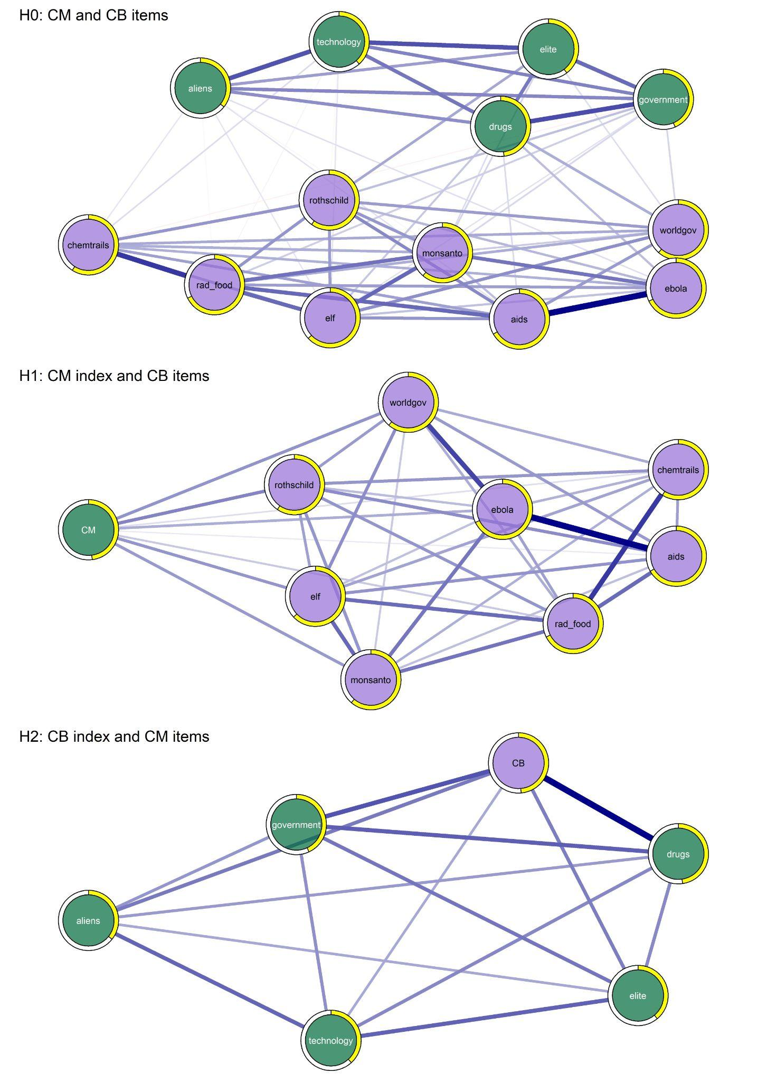
Caption: USA mgm networks. Top: H0 network (all items). Nodes’ color follows EGA and CFA results; yellow pies represent node-wise R². Center: H1 network (CB items, CM index); nodes are colored by construct type. Bottom: H1 network (CM items, CB index).
H1 predicts that controlling for CM should eliminate the manifest correlations among CB items. To test this, we estimated network models in which the CM latent variable (operationalized using the GCB-5 sum score) was included alongside the eight individual CB items from the COMP-CB. The resulting H1 networks for all countries are shown in Figure S5, while the central panel of Figure 1 presents the U.S. results. This panel adopts the same graphical settings as the top panel, with only one difference: node colors now reflect construct membership rather than EGA communities (green for CM and purple for CB). Across all eight countries, CM consistently emerged as a highly peripheral node in the conspiracy belief system, displaying weak and sparse connections to the CB items. To formally assess node importance, we computed Strength centrality and applied non-parametric bootstrapping to estimate its distribution across countries. Figure 2 presents the resulting centrality distributions, with colored violin plots indicating bootstrapped Strength values and black bars denoting 95% confidence intervals. The results provide clear evidence against H1. In every country, CM ranks among the least central nodes in the network. It is consistently the most peripheral in Spain, Italy, Poland, Sweden, and the United States, and among the least central in Germany, Great Britain, and France.
Figure 2: Bootstrapped centrality distributions (H1)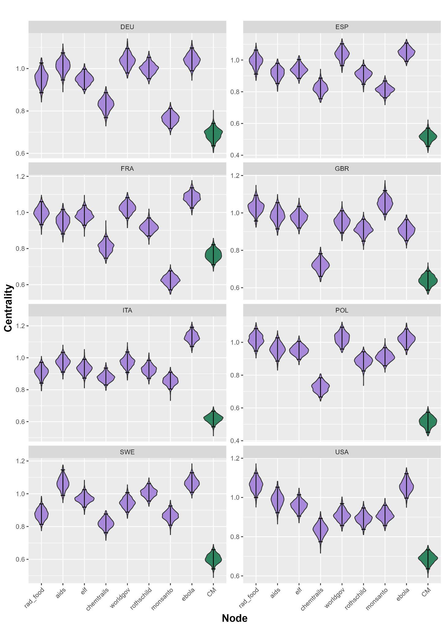Caption: Bootstrapped frequency distributions and CI of node centrality for the H1 networks.
H2 posits that CB, rather than CM, functions as the underlying latent construct, predicting that controlling for CB should eliminate the observed correlations among CM items. To test this hypothesis, we estimated a network model including the CB latent variable (measured via the COMP-CB sum score) alongside the five individual CM items from the GCB-5. The bottom panel of Figure 1 presents results for the United States, while full results for all countries are provided in Figure S6. As with H1, we assessed node centrality using non-parametric bootstrapping. Figure 3 displays the resulting distributions of Strength centrality, with violin plots representing the bootstrapped values and black bars denoting 95% confidence intervals. Across all countries, CB consistently exhibited levels of centrality that were comparable to, or greater than, those of the individual CM items. However, country-level variation emerged. In Germany, France, Great Britain, and the United States, the CB node had higher average centrality than most other components of the network, suggesting a potentially influential role in the structure of CM. By contrast, in Spain, Italy, Poland, and Sweden, the confidence interval for CB’s Strength overlapped substantially with those of most other nodes, indicating that CB’s centrality was not statistically distinguishable from the rest of the network.

Figure 3: Bootstrapped centrality distributions (H2)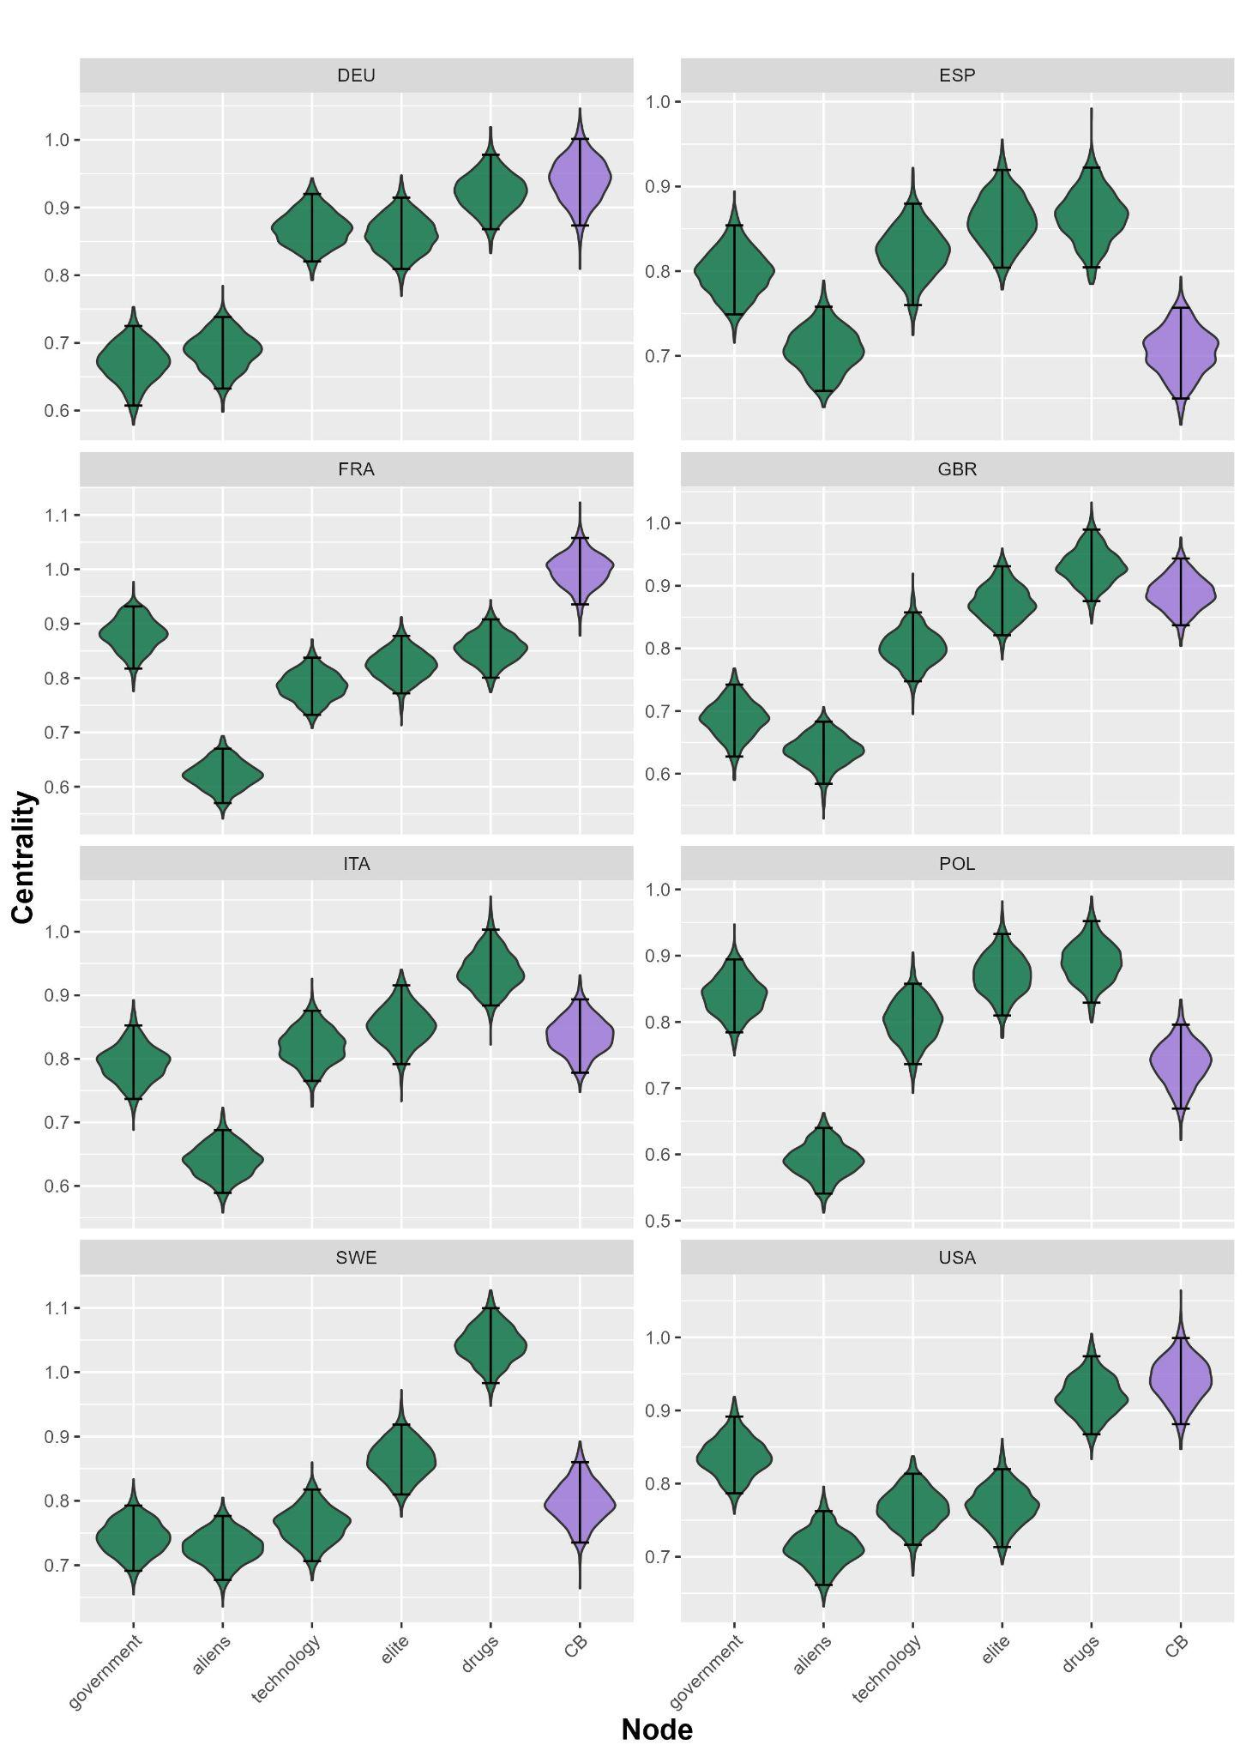Caption: Bootstrapped frequency distributions and CI of node centrality for the H2 networks.
To further evaluate the impact of introducing latent constructs into item-based networks, we examine changes in node-wise R². This provides an additional angle to examine how the relationship between the items of the scales change when adding the two latent variables into the network models. Under H1, incorporating CM into a network composed solely of CB items should increase the explained variance of each node, as CM is theorized to account for their covariation. Under H2, by contrast, adding CB to a network of CM items should produce substantial increases in R², consistent with CB functioning as the underlying construct. Figure 3 offers descriptive evidence on these patterns. The top panel displays bootstrapped node-wise R² values across countries for networks including only CB items (green dots) and those with the CM sum score added (violet dots). Results show that CB-based networks already explain a considerable amount of variance (with R² ranging from 0.50 to 0.75), and that adding CM contributes little or no additional explanatory power. In contrast, the bottom panel compares networks composed only of CM items (violet dots) to those where the CB sum score is added (purple dots). Here, baseline R² values are substantially lower (between 0.20 and 0.45), but the inclusion of CB markedly increases explained variance, especially for the “aliens” and “drugs” items. These findings contradict H1 and support H2, reinforcing the conclusion that CB, rather than CM, plays the more central role in structuring conspiracy belief systems.

Figure 4: Node-wise R² across networks and countries
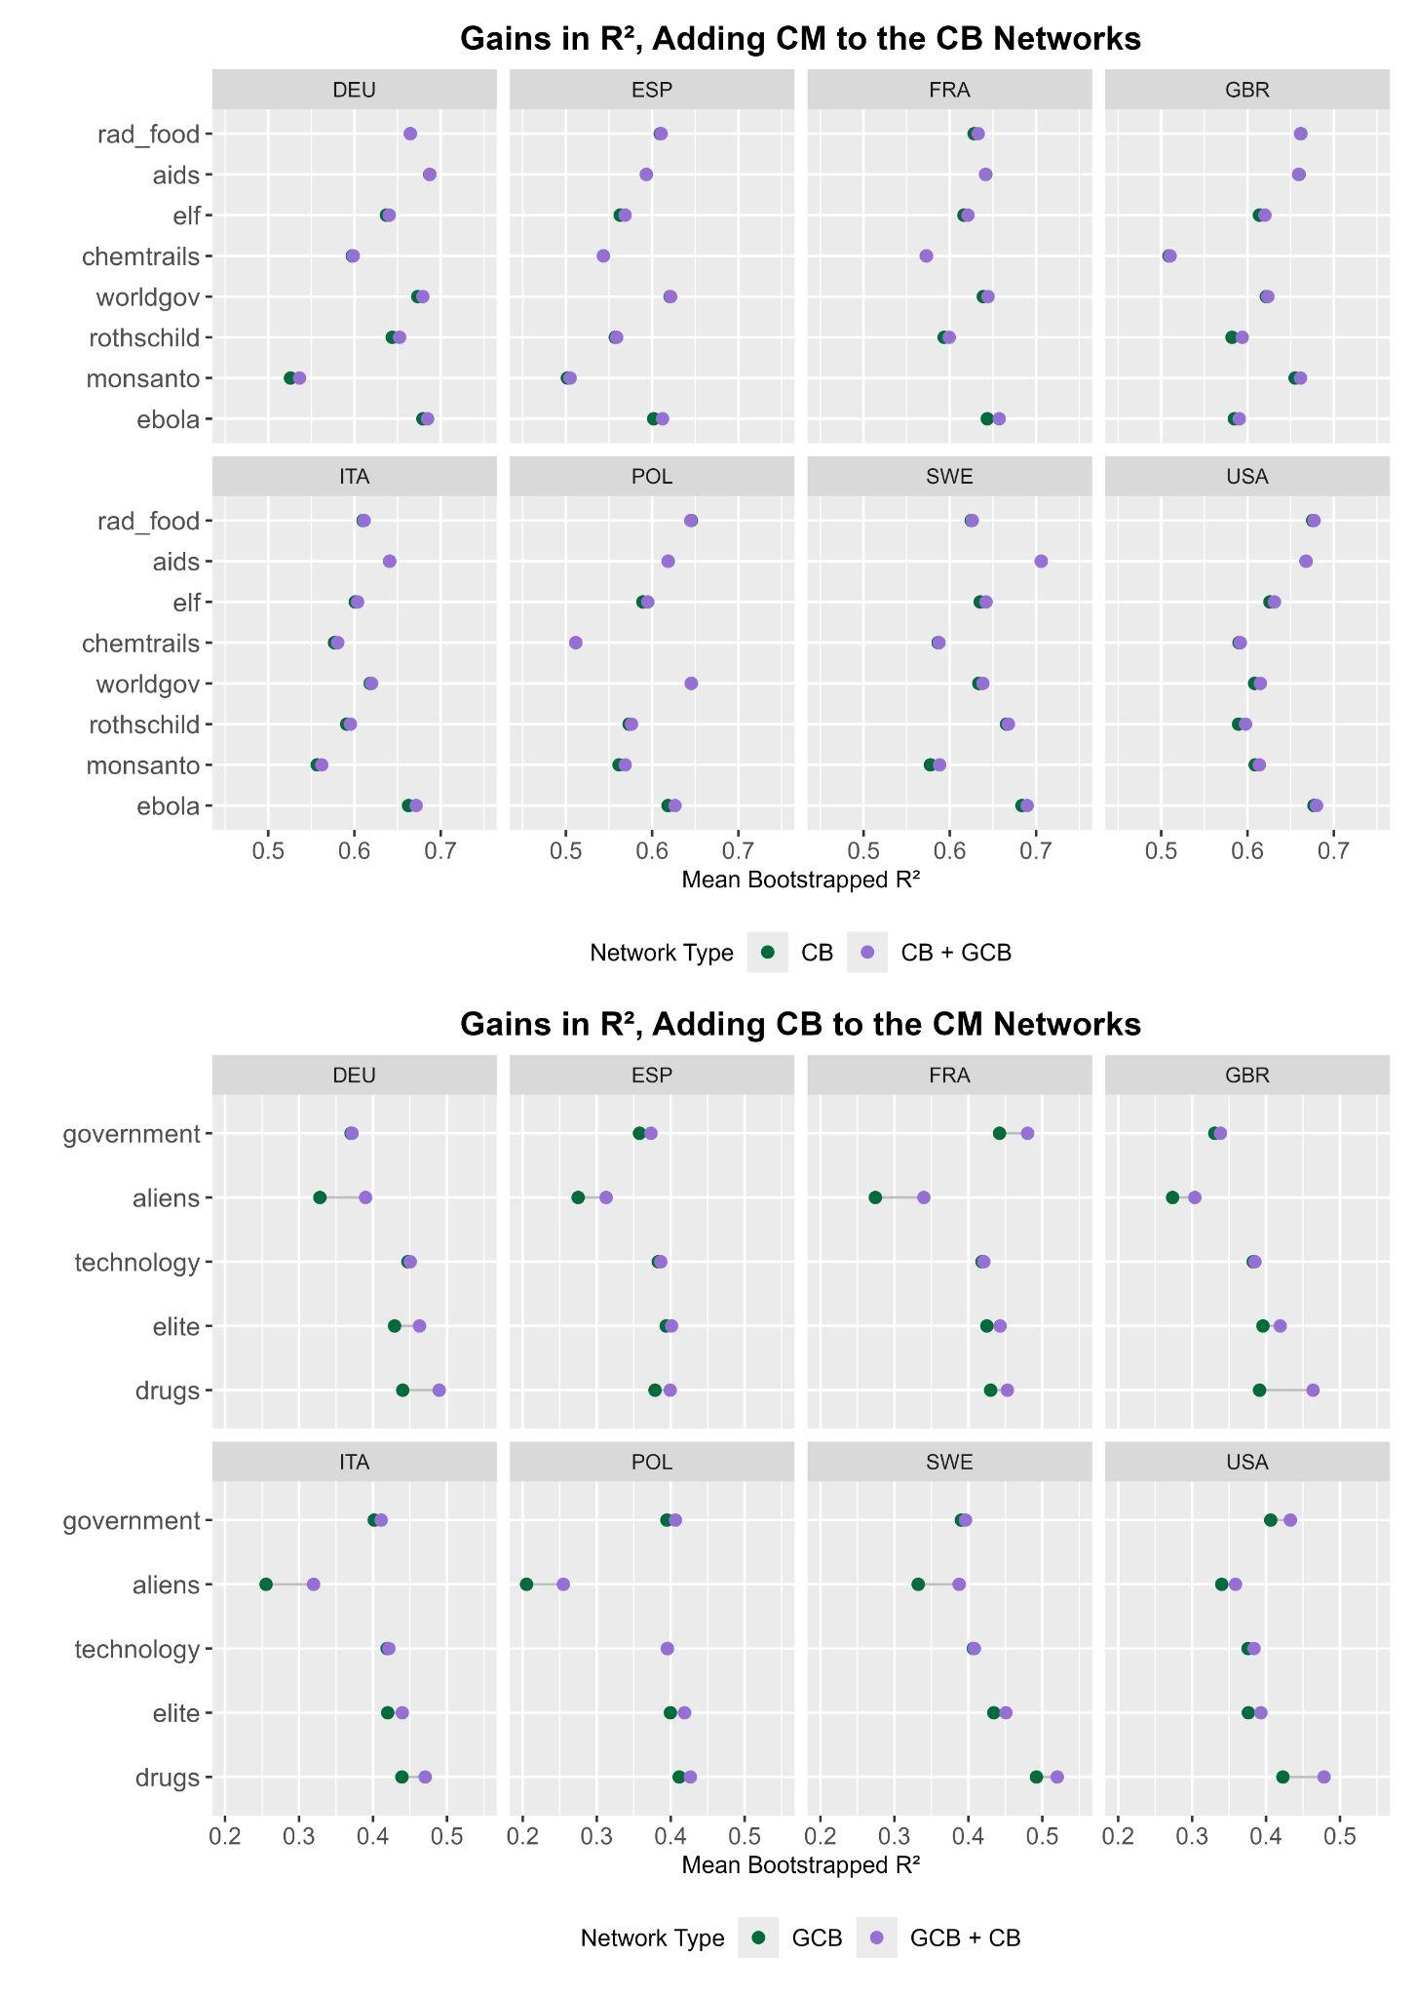Caption: Gains in bootstrapped node-wise R² when adding CM index to network of CB items (top), and CB index to CM networks (bottom).

6. Discussion
Research on Conspiracy Mentality (CM) is shaped by three interrelated debates: its theoretical definition, its causal relationship with Conspiracy Beliefs (CB), and its empirical utility. We argue that assessing the utility of CM is premature without first establishing the validity of CM measures. This requires more than correlational evidence with external variables; it demands theoretical clarity about the defining features of CM and empirical scrutiny of its relationship with CB. To this end, we analyzed large, representative samples from eight countries using two cross-nationally validated instruments: the COMP-CB for CB (Mancosu et al., 2025), and the GCB-5 for CM (Dagnall et al., 2023; Kay & Slovic, 2023). This comparative design enabled us to test three competing hypotheses: whether CB and CM are empirically distinct constructs (H0); whether CM operates as a latent factor underlying CB (H1); or whether CB, instead, drives CM (H2). To evaluate these hypotheses, we employed state-of-the-art network psychometric models (Borsboom et al., 2021). Unlike latent variable approaches, which assume local independence and a common underlying cause, network models allow for the direct estimation of inter-item dependencies. This framework is particularly well-suited for investigating conspiracy belief systems, which emerge from the interactions between belief in specific conspiracy theories, and generic conspiratorial attitudes.
H0 tested whether CM and CB are empirically distinct constructs. While prior work suggested that respondents interpret CM and CB items differently (Trella et al., 2024), the isomorphic view—treating them as interchangeable—remains implicit in much of the literature (Nera, 2024; Sutton et al., 2024). The psychometric properties of the comparative scales we used aligned with prior research. Indeed, CM items were on average more endorsed than CB ones; moreover, mentality was normally distributed in all countries, while CB skewed to the left (Imhoff et al., 2022). Importantly, this entails that CB items were endorsed only by a subset of those high in CM. Furthermore, our findings supported H0, as EGA consistently identified two distinct network communities, and CFA showed good model fit in all countries. Finally, an analysis of node-wise R² values in the network models composed of all items (top panel of Figure 1 for the US case, Figure S3 for all country networks) showed that these models explained substantially more variance in CB items (R² always higher than 0.5) than in CM ones (R² always lower than 0.5).
Be it defined as a tendency (Imhoff et al., 2022), as a generalized political attitude (Imhoff & Bruder, 2014), or as a worldview (Sutton et al., 2024), the dominant approach assumes that CM precedes CB (Strömbäck et al., 2024). However, alternative accounts suggest that the levels of CB might change independently from those of CM (Wang & Van Prooijen, 2023), that CB might drive CM (Granados Samayoa et al., 2022), or that CB might causally interact with positive feedback loops (Williams et al., 2025). These competing views led to H1, which predicted that adding the CM latent variable to a CB network should eliminate inter-item correlations, and H2, which predicted the same effect when adding the CB latent variable to a CM network.
Our results contradicted H1: CM was remarkably peripheral in all national conspiracy belief systems. In contrast, H2 received more support. The CB sum score exhibited greater centrality in CM networks, suggesting that CB may have a stronger structural role in shaping CM than the reverse. While this is not conclusive evidence of a reversed latent model where CB determines CM, it is strong evidence against the dominant model where CM precedes CB. Differences in bootstrapped node-wise R² further reinforced this asymmetry. Across all countries, the variance of CB items was extremely well captured by other CB items, whereas the variance of CM items was considerably lower. This suggests that CB levels are largely determined by other CB, while CM levels depend to a greater extent on factors outside our models, requiring explanations beyond the conspiracy belief system itself (Haslbeck & Waldorp, 2018).
These findings support two possible interpretations. If a latent generative mechanism underpins CM and CB, our results indicate that only CM’s variance is available for exploitation, meaning CM does not meaningfully enhance predictions of CB. Alternatively, the results align with a network model, where CB reinforce each other and form a self-sustaining system independent of CM (Barkun, 2013; Goertzel, 1994; Williams et al., 2022).
Our study has limitations. With regard to H0, while we provide strong evidence for a bi-dimensional structure distinguishing CB and CM, future research should further test the dimensionality of these constructs using alternative validated scales. We relied on the GCB-5 and on the COMP-CB due to their demonstrated cross-national applicability, but results may differ when using other CM instruments (e.g.: Bruder et al., 2013; Stojanov & Halberstadt, 2019).
Concerning H1 and H2, the cross-sectional nature of our data precludes strong causal inference. Yet, our use of network psychometrics offers a novel framework for testing competing models of the CB–CM relationship, enabling a rigorous comparative investigation. Specifically, we assessed whether the observed data aligned with dominant latent variable models in which CM drives CB, or with an alternative account in which CB drives CM. As discussed above, our results provided stronger support for the latter, though they do not establish its causal validity or rule out the possibility that conspiracist thinking emerges from a networked data generation mechanism (Williams et al., 2022). While we encourage future research employing longitudinal or experimental designs to clarify the features of this relationship, we argue that our study makes a significant contribution to the literature. Specifically, we leveraged cross-sectional comparative data and network modeling to critically assess the empirical plausibility of competing theoretical accounts of conspiracism.

7. Conclusions
If CM should not be judged on the grounds of its utility, its validity must come into question. Developing survey instruments for an ill-defined construct risks making measurement a process that generates rather than reflecting. The danger is that measuring CM creates CM, meaning that each measurement approach produces a different version of the construct. This would challenge the realist ontology of latent variable models, reinforcing a constructivist paradigm instead.
Our findings indicate that if CM were truly the driver of CB, the CM latent variable would be the most central component of the conspiracy belief system. Yet, the sum score of the GCB-5 emerged as a peripheral node in all countries. Moreover, the node-wise R² of CM items were drastically lower than those of CB items, suggesting that beliefs in real-world conspiracies is an excellent predictor of believing in other CB, whereas modelling a conspiratorial mindset requires factors which were not featured in our models. This suggests that CM does not cover the role it was designed to fulfill. Thus, in case of limited budget, we encourage future research on the topic to include CB, rather than CM, measures.
More broadly, this study highlights the need to develop diverse, context-sensitive CB batteries, rather than relying on a single, overarching conspiracist tendency. It may be particularly valuable to design batteries that reflect different political orientations and thematic domains (Enders et al., 2021), and that account for both the powerful and the powerless as potential conspirators (Nera et al., 2021). These instruments should be regularly updated, rather than treated as static, pure measures. Measurement is not an exercise in purity, it is an effort to capture reality as it is: content-contaminated and evolving. Therefore there is no intrinsic virtue in purity, only in validity.

8. Bibliography
Barkun, M. (2013). A culture of conspiracy: Apocalyptic visions in contemporary America (Vol. 15). Univ of California Press.
Borsboom, D. (2017). A network theory of mental disorders. World Psychiatry, 16(1), 5–13. https://doi.org/10.1002/wps.20375
Borsboom, D., Cramer, A. O., Kievit, R. A., Scholten, A. Z., & Franić, S. (2009). The end of construct validity. The Concept of Validity: Revisions, New Directions and Applications, Oct, 2008.
Borsboom, D., Deserno, M. K., Rhemtulla, M., Epskamp, S., Fried, E. I., McNally, R. J., Robinaugh, D. J., Perugini, M., Dalege, J., Costantini, G., Isvoranu, A.-M., Wysocki, A. C., Borkulo, C. D. van, Bork, R. van, & Waldorp, L. J. (2021). Network analysis of multivariate data in psychological science. Nature Reviews Methods Primers, 1(1), 58. https://doi.org/10.1038/s43586-021-00055-w
Borsboom, D., Mellenbergh, G. J., & Van Heerden, J. (2003). The theoretical status of latent variables. Psychological Review, 110(2), 203–219. https://doi.org/10.1037/0033-295X.110.2.203
Borsboom, D., Mellenbergh, G. J., & Van Heerden, J. (2004). The Concept of Validity. Psychological Review, 111(4), 1061–1071. https://doi.org/10.1037/0033-295X.111.4.1061
Brandt, M. J., & Sleegers, W. W. A. (2021). Evaluating Belief System Networks as a Theory of Political Belief System Dynamics. Personality and Social Psychology Review, 25(2), 159–185. https://doi.org/10.1177/1088868321993751
Bringmann, L. F., Elmer, T., Epskamp, S., Krause, R. W., Schoch, D., Wichers, M., Wigman, J. T. W., & Snippe, E. (2019). What do centrality measures measure in psychological networks? Journal of Abnormal Psychology, 128(8), 892–903. https://doi.org/10.1037/abn0000446
Brotherton, R., French, C. C., & Pickering, A. D. (2013). Measuring Belief in Conspiracy Theories: The Generic Conspiracist Beliefs Scale. Frontiers in Psychology, 4. https://doi.org/10.3389/fpsyg.2013.00279
Bruder, M., Haffke, P., Neave, N., Nouripanah, N., & Imhoff, R. (2013). Measuring Individual Differences in Generic Beliefs in Conspiracy Theories Across Cultures: Conspiracy Mentality Questionnaire. Frontiers in Psychology, 4. https://doi.org/10.3389/fpsyg.2013.00225
Burger, J., Isvoranu, A.-M., Lunansky, G., Haslbeck, J. M. B., Epskamp, S., Hoekstra, R. H. A., Fried, E. I., Borsboom, D., & Blanken, T. F. (2023). Reporting standards for psychological network analyses in cross-sectional data. Psychological Methods, 28(4), 806–824. https://doi.org/10.1037/met0000471
Converse, P. E. (2006). The nature of belief systems in mass publics (1964). Critical Review, 18(1–3), 1–74. https://doi.org/10.1080/08913810608443650
Dablander, F., & Hinne, M. (2019). Node centrality measures are a poor substitute for causal inference. Scientific Reports, 9(1), 6846. https://doi.org/10.1038/s41598-019-43033-9
Dagnall, N., Denovan, A., Drinkwater, K. G., & Escolà-Gascón, A. (2023). The Generic Conspiracist Beliefs Scale-5: Further psychometric evaluation using a United Kingdom-based sample. Frontiers in Psychology, 14, 1303838. https://doi.org/10.3389/fpsyg.2023.1303838
Douglas, K. M., & Sutton, R. M. (2023). What Are Conspiracy Theories? A Definitional Approach to Their Correlates, Consequences, and Communication. Annual Review of Psychology, 74(1), 271–298. https://doi.org/10.1146/annurev-psych-032420-031329
Enders, A. M., Diekman, A., Klofstad, C., Murthi, M., Verdear, D., Wuchty, S., & Uscinski, J. (2023). On modeling the correlates of conspiracy thinking. Scientific Reports, 13(1), 8325. https://doi.org/10.1038/s41598-023-34391-6
Enders, A. M., Uscinski, J. E., Klofstad, C. A., Seelig, M. I., Wuchty, S., Murthi, M. N., Premaratne, K., & Funchion, J. R. (2021). Do conspiracy beliefs form a belief system? Examining the structure and organization of conspiracy beliefs. Journal of Social and Political Psychology, 9(1), 255–271. https://doi.org/10.5964/jspp.5649
Epskamp, S., Maris, G., Waldorp, L. J., & Borsboom, D. (2018). Network psychometrics. The Wiley Handbook of Psychometric Testing: A Multidisciplinary Reference on Survey, Scale and Test Development, 953–986.
Epskamp, S., Waldorp, L. J., Mõttus, R., & Borsboom, D. (2018). The Gaussian Graphical Model in Cross-Sectional and Time-Series Data. Multivariate Behavioral Research, 53(4), 453–480. https://doi.org/10.1080/00273171.2018.1454823
Friedman, J., Hastie, T., & Tibshirani, R. (2008). Sparse inverse covariance estimation with the graphical lasso. Biostatistics, 9(3), 432–441. https://doi.org/10.1093/biostatistics/kxm045
Goertzel, T. (1994). Belief in Conspiracy Theories. Political Psychology, 15(4), 731. https://doi.org/10.2307/3791630
Golino, H., & Christensen, A. (2025). EGAnet: Exploratory Graph Analysis – A framework for estimating the number of dimensions in multivariate data using network psychometrics [Manual]. https://doi.org/10.32614/CRAN.package.EGAnet
Golino, H. F., Epskamp, S., & Voracek, M. (2017). Exploratory graph analysis: A new approach for estimating the number of dimensions in psychological research. PLOS ONE, 12(6), e0174035. https://doi.org/10.1371/journal.pone.0174035
Golino, H., Shi, D., Christensen, A. P., Garrido, L. E., Nieto, M. D., Sadana, R., Thiyagarajan, J. A., & Martinez-Molina, A. (2020). Investigating the performance of exploratory graph analysis and traditional techniques to identify the number of latent factors: A simulation and tutorial. Psychological Methods, 25(3), 292–320. https://doi.org/10.1037/met0000255
Granados Samayoa, J. A., Moore, C. A., Ruisch, B. C., Boggs, S. T., Ladanyi, J. T., & Fazio, R. H. (2022). A gateway conspiracy? Belief in COVID-19 conspiracy theories prospectively predicts greater conspiracist ideation. PLOS ONE, 17(10), e0275502. https://doi.org/10.1371/journal.pone.0275502
Haslbeck, J. M. B., & Waldorp, L. J. (2018). How well do network models predict observations? On the importance of predictability in network models. Behavior Research Methods, 50(2), 853–861. https://doi.org/10.3758/s13428-017-0910-x
Haslbeck, J. M. B., & Waldorp, L. J. (2020). mgm: Estimating Time-Varying Mixed Graphical Models in High-Dimensional Data. Journal of Statistical Software, 93(8). https://doi.org/10.18637/jss.v093.i08
Imhoff, R. (2024). On the Usefulness of the Conspiracy Mentality Concept. Zeitschrift Für Psychologie, 232(1), 59–63. https://doi.org/10.1027/2151-2604/a000550
Imhoff, R., Bertlich, T., & Frenken, M. (2022). Tearing apart the “evil” twins: A general conspiracy mentality is not the same as specific conspiracy beliefs. Current Opinion in Psychology, 46, 101349. https://doi.org/10.1016/j.copsyc.2022.101349
Imhoff, R., & Bruder, M. (2014). Speaking (Un–)Truth to Power: Conspiracy Mentality as A Generalised Political Attitude. European Journal of Personality, 28(1), 25–43. https://doi.org/10.1002/per.1930
Kay, C. S., & Slovic, P. (2023). The generic conspiracist beliefs scale – 5: A short-form measure of conspiracist ideation. Journal of Research in Personality, 102, 104315. https://doi.org/10.1016/j.jrp.2022.104315
Lantian, A., Muller, D., Nurra, C., & Douglas, K. M. (2016). Measuring Belief in Conspiracy Theories: Validation of a French and English Single-Item Scale. International Review of Social Psychology, 29(1), 1. https://doi.org/10.5334/irsp.8
Mancosu, M., Bertero, A., & Vegetti, F. (2025). Measuring Belief in Conspiracy Theories Across Borders: A Cross- National Psychometric Approach. In Review. https://doi.org/10.21203/rs.3.rs-7138689/v1
Nera, K. (2024). Analyzing the Causation Between Conspiracy Mentality and Belief in Conspiracy Theories: Potential Pitfalls and Leads to Address Them. Zeitschrift Für Psychologie, 232(1), 44–49. https://doi.org/10.1027/2151-2604/a000533
Nera, K., Wagner‐Egger, P., Bertin, P., Douglas, K. M., & Klein, O. (2021). A power‐challenging theory of society, or a conservative mindset? Upward and downward conspiracy theories as ideologically distinct beliefs. European Journal of Social Psychology, 51(4–5), 740–757. https://doi.org/10.1002/ejsp.2769
Opsahl, T., Agneessens, F., & Skvoretz, J. (2010). Node centrality in weighted networks: Generalizing degree and shortest paths. Social Networks, 32(3), 245–251. https://doi.org/10.1016/j.socnet.2010.03.006
Pasternak, B. L., Hayward, M., & Harari, M. (2002). Doctor Zhivago. Vintage.
Pilch, I., Turska-Kawa, A., Wardawy, P., Olszanecka-Marmola, A., & Smołkowska-Jędo, W. (2023). Contemporary trends in psychological research on conspiracy beliefs. A systematic review. Frontiers in Psychology, 14, 1075779. https://doi.org/10.3389/fpsyg.2023.1075779
Pons, P., & Latapy, M. (2005). Computing Communities in Large Networks Using Random Walks.
Popper, K. R. (2019). The conspiracy theory of society. In Conspiracy theories (pp. 13–15). Routledge.
Stojanov, A., & Halberstadt, J. (2019). The Conspiracy Mentality Scale: Distinguishing Between Irrational and Rational Suspicion. Social Psychology, 50(4), 215–232. https://doi.org/10.1027/1864-9335/a000381
Strömbäck, J., Broda, E., Tsfati, Y., Kossowska, M., & Vliegenthart, R. (2024). Disentangling the Relationship Between Conspiracy Mindset Versus Beliefs in Specific Conspiracy Theories. Zeitschrift Für Psychologie, 232(1), 18–25. https://doi.org/10.1027/2151-2604/a000546
Sutton, R. M., & Douglas, K. M. (2020). Conspiracy theories and the conspiracy mindset: Implications for political ideology. Current Opinion in Behavioral Sciences, 34, 118–122. https://doi.org/10.1016/j.cobeha.2020.02.015
Sutton, R. M., Douglas, K. M., & Trella, C. (2024). Conspiracy Mentality Versus Belief in Conspiracy Theories: Response to Nera and Some Recommendations for Researchers. Zeitschrift Für Psychologie, 232(1), 50–54. https://doi.org/10.1027/2151-2604/a000549
Trella, C., Sutton, R. M., & Douglas, K. M. (2024). Semantic and Causal Relations Between the Conspiracy Mentality and Belief in Conspiracy Theories. Zeitschrift Für Psychologie, 232(1), 7–17. https://doi.org/10.1027/2151-2604/a000545
Uscinski, J. E., & Parent, J. M. (2014). American conspiracy theories. Oxford University Press.
Van Der Maas, H. L. J., Dolan, C. V., Grasman, R. P. P. P., Wicherts, J. M., Huizenga, H. M., & Raijmakers, M. E. J. (2006). A dynamical model of general intelligence: The positive manifold of intelligence by mutualism. Psychological Review, 113(4), 842–861. https://doi.org/10.1037/0033-295X.113.4.842
Van Prooijen, J.-W., Wahring, I., Mausolf, L., Mulas, N., & Shwan, S. (2023). Just Dead, Not Alive: Reconsidering Belief in Contradictory Conspiracy Theories. Psychological Science, 34(6), 670–682. https://doi.org/10.1177/09567976231158570
VandenBos, G. R. (2007). APA dictionary of psychology. American Psycho-Logical Association.
Wang, H., & Van Prooijen, J. (2023). Stolen elections: How conspiracy beliefs during the 2020 American presidential elections changed over time. Applied Cognitive Psychology, 37(2), 277–289. https://doi.org/10.1002/acp.3996
Williams, M. N., Marques, M. D., Hill, S. R., Kerr, J. R., & Ling, M. (2022). Why are beliefs in different conspiracy theories positively correlated across individuals? Testing monological network versus unidimensional factor model explanations. British Journal of Social Psychology, 61(3), 1011–1031. https://doi.org/10.1111/bjso.12518
Williams, M. N., Marques, M. D., Kerr, J. R., Hill, S. R., Ling, M., & Clarke, E. J. R. (2025). Does Developing a Belief in One Conspiracy Theory Lead a Person to be More Likely to Believe in Others? European Journal of Social Psychology, ejsp.3153. https://doi.org/10.1002/ejsp.3153
Wood, M. J., Douglas, K. M., & Sutton, R. M. (2012). Dead and Alive: Beliefs in Contradictory Conspiracy Theories. Social Psychological and Personality Science, 3(6), 767–773. https://doi.org/10.1177/1948550611434786

Endnotes
1: Indeed, these labels are clearly not interchangeable. A tendency refers to a recurring behavioral, cognitive, or affective inclination, an attitude is a synthetic evaluation of an attitude object, and a worldview (Weltanschauung) is a fundamental understanding of the universe and humankind’s place in it (VandenBos, 2007).
2: For instance, the OICM of Lantian and colleagues (2016) taps CM through the single item “I think that the official version of the events given by authorities very often hides the truth”. The CMQ features the item: “events which superficially seem to lack a connection are often the result of secret activities” (Bruder et al., 2013). Similarly, the ACTS scale assesses endorsement of statements such as “much of our lives are being controlled by plots hatched in secret places” (Uscinski & Parent, 2014).

